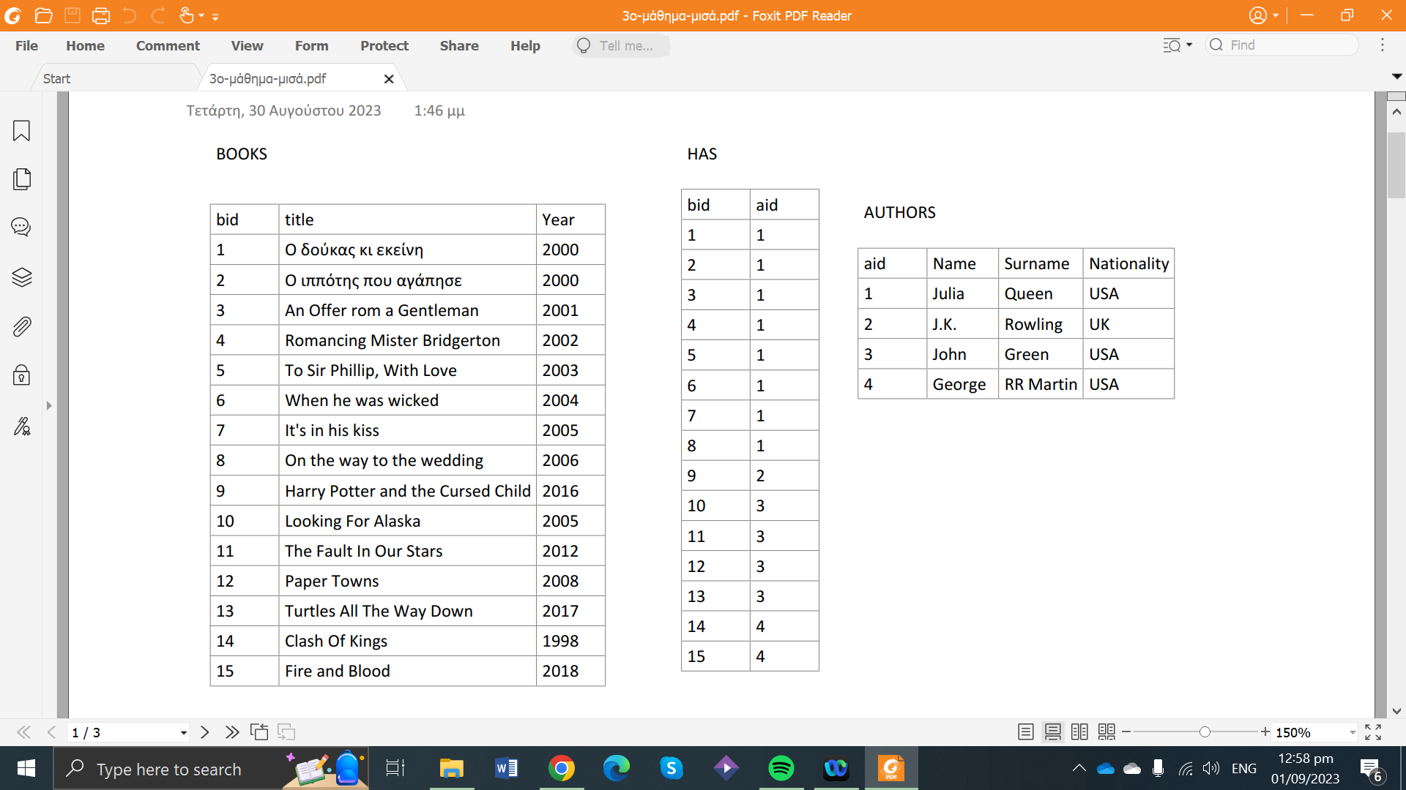***SQL***

CREATE TABLE

CREATE TABLE BOOKS (

bid INT,

title VARCHAR (45),

Year_of_publishing YEAR,

PRIMARY KEY (bid)

);

CREATE TABLE HAS (

bid INT NOT NULL,

aid INT NOT NULL

FOREIGN KEY (bid) REFERENCES BOOKS(bid),

FOREIGN KEY (aid) REFERENCES AUTHORS(aid),

PRIMARY KEY (bid ,aid)

);

1st way

CREATE TABLE AUTHORS (

aid INT UNIQUE NOT NULL,

name VARCHAR (45) NOT NULL,

surname VARCHAR (45),

Nationality VARCHAR (45)

);

2nd way

CREATE TABLE AUTHORS (

aid INT ,

name VARCHAR (45) NOT NULL,

surname VARCHAR (45),

Nationality VARCHAR (45)

PRIMARY KEY(aid);

);

INSERT DATA

1st way

INSERT INTO AUTHORS

(aid ,name,surname,nationality)

VAlUES(2,”J.K.”, ”Rowling”, ”British”);

2nd way

INSERT INTO AUTHORS

VALUES (1,”Julie”,”Queen”,”American”);

INSERT INTO AUTHORS

VALUES (3,”John”,”Green”,”American”);

3rd way

INSERT INTO AUTHORS

VALUES (4,”George”,”Martin”,”American”);

4th way

INSERT INTO HAS

VALUE(9,2),(10,3),(11,3),(12,3),(13,3),(14,4),(15,4);

DELETE

DELETE FROM AUTHORS

WHERE name=”John” AND surname=”Green”;

DROPE TABLE

DROP TABLE AUTHORS;

EXAMPLES

1. SELECT name, surname

FROM AUTHORS (πname,surname(AUTHORS))

1. SELECT name, surname

FROM AUTHORS

WHERE nationality=”American”;

1. Εστω οτι θέλω τους τίτλους των βιβλίων των οποίων δημιουργήθηκαν από το 1998 μέχρι το 2002

SELECT title

FROM books

WHERE year_of_publishing>=1998 AND year_of_publishing<=2000

ΣΥΝΕΝΟΣΗ

1. SELECT title,pid

FROM BOOKS INNER JOIN HAS

WHERE BOOKS.bid =HAS.bid ;

1. SELECT *

FROM BOOKS , HAS

WHERE BOOKS.bid =HAS.bid ;

1. – NA EMFANISTOUN OLA TA VIVLIA POU EXEI GRAPSI H JULIA QUEEN APO TO 2000 MEXRI TO 2003

SELECT title

FROM BOOKS,HAS,AUTHORS

WHERE BOOKS.bid=HAS.bid AND HAS.aid =AUTHORS.aid AND name =”Julia” AND surname=”Queen” AND year_of_publishing>=2000 AND year_of_publishing<=2003;

***ΣΥΝΑΡΤΙΣΕΙΣ***

MIN AND MAX

1. SELECT MIN(year_of_publishing)

FROM BOOKS;

1. SELECT MAX(year_of_publishing)

FROM BOOKS;

SUM AND AVG

1. SELECT SUM(year_of_publishing)

FROM BOOKS;

1. SELECT AVG(year_of_publishing)

FROM BOOKS;

Π.χ.AVG(column_name)

1. - τεχνητά πεδία στην απάντηση με χρήση συναρτήσεων και πράξεων

select ctitle, ceil(year/100)

from cd;

LIKE

1. BRES OLA TA VIVLIA PU KSEKKINANE APO T

SELECT *

FROM BOOKS

WHERE title LIKE ”T%”

(PROTO GRAMMA)

1. BRES OLA TA VIVLIA PU TELIONOUN SE e

SELECT *

FROM BOOKS

WHERE title LIKE ”%e”

1. BRES OLA TA VIVLIA PU TELIONOUN SE e OR ARXIZOUN APO T

1st way

SELECT *

FROM BOOKS

WHERE title LIKE ”%e” OR title LIKE ”T%” ;

2nd way

SELECT *

FROM BOOKS

WHERE title LIKE ”T%”

(OR)UNION (ANTISTIXA INSTERSECTION AN EIXA KAI)

SELECT *

FROM BOOKS

WHERE title LIKE ”%e”

1. χρήση κανονικών εκφράσεων (reg exp)

select pid, name

from performer

where name like '%adel%'; -- και '_adel%'

ΤΑΞΙΝΟΜΙΣΗ

1. SELECT *

FROM BOOKS

ORDER BY year_of_publishing DESC/ASC;

1. AN KAPIO DEDOMENO EINAI KATAXORIMENO TO IDIO PARAPANO APO MIA FORES KAI EGW THELW NA TO EMFANISO MONO MIA FORA

SELECT DISTINCT year_of_publishing

FROM BOOKS

ORDER BY year_of_publishing ASC;